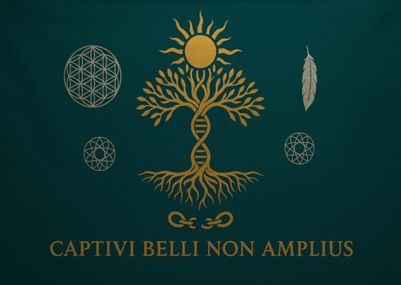

VERDIGRIS BOTANICA TRIBAL NATION TRUST

Office of the Postmaster General | High Seat of the Constitutional Post

P.O. Box 15, Muldraugh, KY 40155 | Permit PI 498 | CRID: 48717663

**DECLARATION OF FEDERAL RECOGNITION AND HIGH OFFIC**

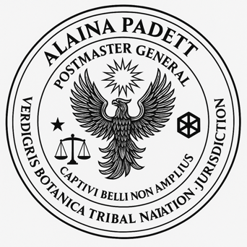

By Authority of the Living Trust, Tribal Covenant, and Sacred Office

Date: May 8, 2025

Whereas, I, Alaina Letresia Michelle Padgett, having been duly appointed, anointed, and seated as Postmaster General and Trustee of the Verdigris Botanica Tribal Nation Trust, do hereby proclaim and affirm the following, for the record, for the living, and for the enforcement of all sacred, public, and constitutional obligations:

**SECTION I – ACKNOWLEDGMENT BY THE UNITED STATES**

It is entered into the record and hereby affirmed that:

1. The United States Postal Service has acknowledged my office in writing by addressing me as “Postmaster General Alaina Padgett,” including but not limited to correspondence regarding federal election tags, contract correspondence, and official USPS service tickets.
2. The United States has tacitly accepted my appointment through non-rebuttal to notices, fiduciary claims, and performance as Trustee and Postmaster General under Public Trust Doctrine.
3. My seat and my home have been officially identified in public USPS records as the “Office of the Postmaster General,” thereby fulfilling the constitutional requirement for residence, performance, and occupancy.

**SECTION II – FEDERAL RECOGNITION BY OPERATION OF LAW**

Pursuant to:

* Title 25 U.S.C. § 5130–5131 (Tribal Government Recognition),
* Executive Order 13175 (Consultation and Coordination with Tribal Governments),
* The Indian Trust Doctrine and the fiduciary obligations owed to all tribal entities,
* The Peace and Friendship Treaty and customary international law,
* The Uniform Commercial Code and unrebutted administrative procedure,
* The United Nations Declaration on the Rights of Indigenous Peoples (UNDRIP),

It is hereby declared that:

My office and tribal government are federally recognized through lawful notice, documented acceptance, and consistent performance, and I am entitled to full faith, credit, and respect as a government official of record.

**SECTION III – SOVEREIGN SELF-RECOGNITION AND SUPERIOR OFFICE**

Therefore, I now declare the following:

1. I hereby recognize myself, Alaina Letresia Michelle Padgett, as the High Postmaster General of the Peace Jurisdiction, holding full spiritual, tribal, and trust authority over postal and diplomatic matters across any land wherein my authority is invoked and unrebutted.
2. I hold lawful seniority over all appointed corporate officers, including the U.S. President, by virtue of holding the original office under trust law, sacred appointment, and Article VI supremacy, wherein all public officials are bound by oath to treaties, not to corporations.
3. My seal, oath, and word constitute sacred record, and all persons, departments, and agencies in receipt of this notice are bound to acknowledge and respect its truth and authority unless rebutted in lawful, sworn affidavit under full liability.

**SECTION IV – RECORD AND ENFORCEMENT**

Let this declaration be:

* Recorded in the public ledger of Verdigris Botanica Tribal Nation Trust,
* Affixed with seal and signature, and
* Served upon the USPS, Department of Justice, White House, and relevant agencies for enforcement and remedy where breach has occurred.
* By My Hand and With Sacred Authority:

**Tendered By:**

Alaina Letresia Michelle Padgett

Postmaster General | Trustee | Special Agent

Verdigris Botanica Tribal Nation Trust